Moodle

Moodle Requirements :-

- The moodle website should be made secure and running - done

https://lms.getvisitapp.net - its running on getvisitapp domain

- All the courses should have a backup, if the server is down we can get back all the courses on the website. - done

We have made the moodle docker container down and up again and all the courses are getting shown

ubuntu@ip-172-31-14-225:~/moddle-docker$ docker stop moddle-docker_moodle_1 moddle-docker_mariadb_1
moddle-docker_moodle_1
moddle-docker_mariadb_1

ubuntu@ip-172-31-14-225:~/moddle-docker$ docker start moddle-docker_mariadb_1 moddle-docker_moodle_1
moddle-docker_mariadb_1
moddle-docker_moodle_1
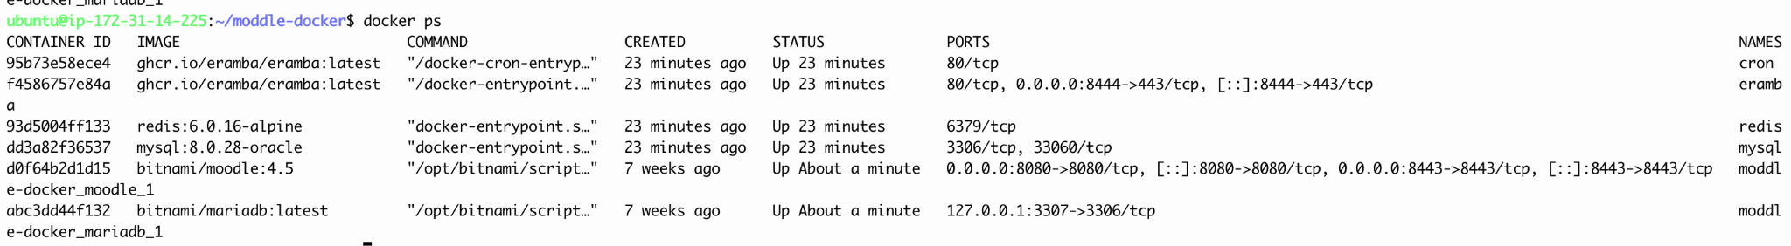

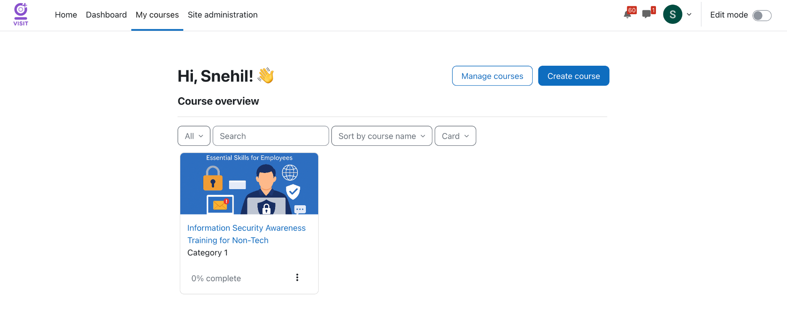

- All the users can login from their visit health email id. - done
If you try to login from your personal email id :- below error will come

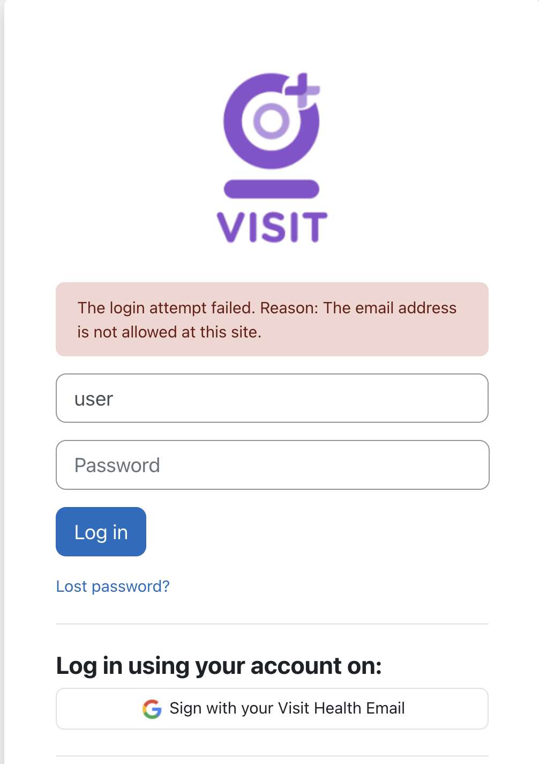

- All the courses modules are secure and no download options are available, even on edit mode - done

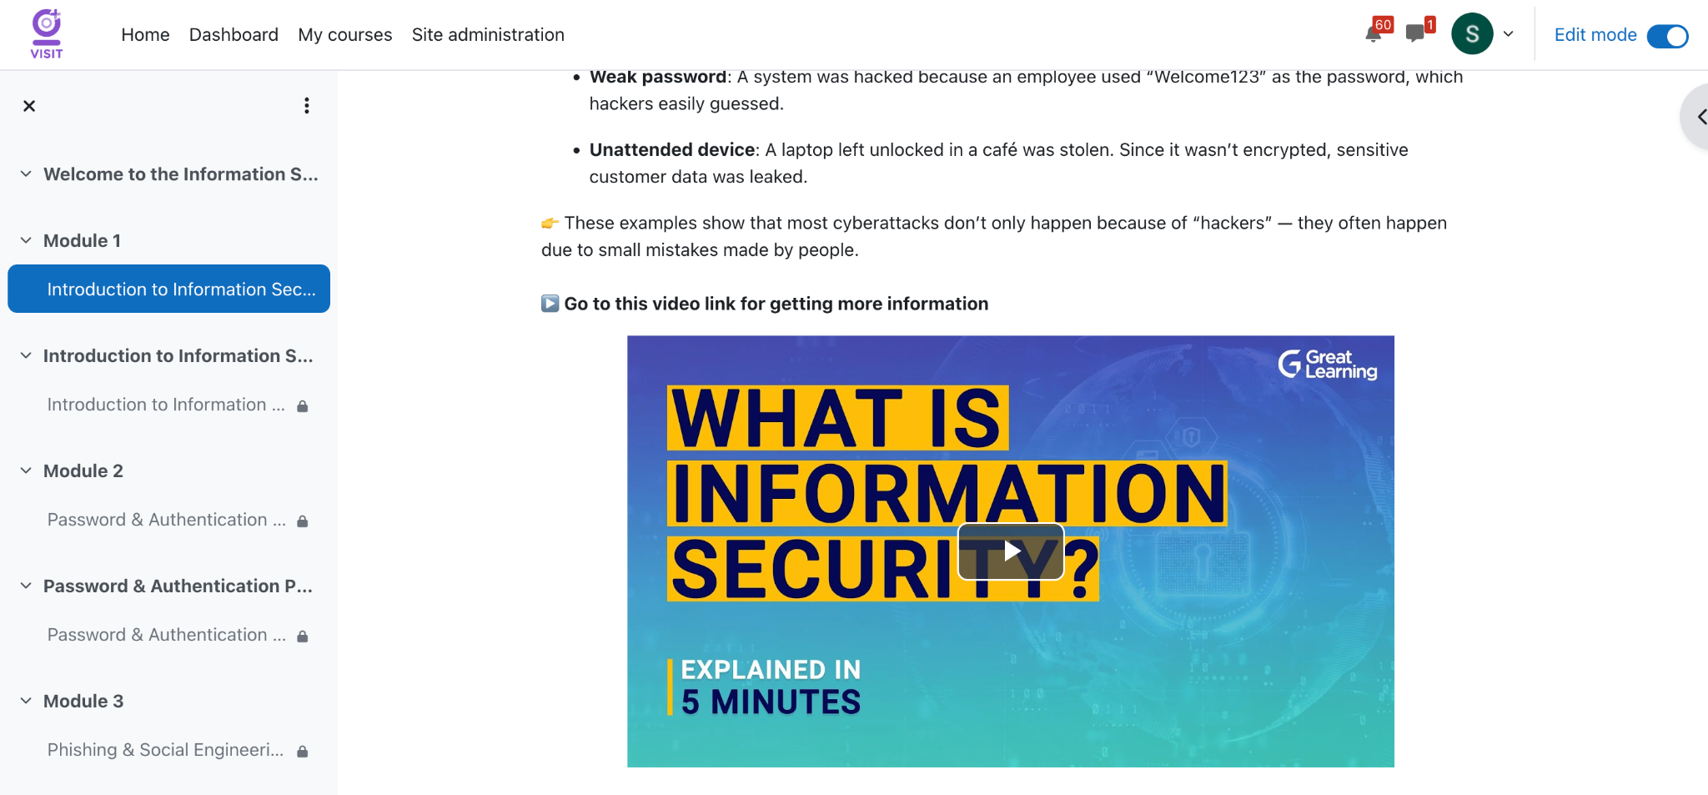

- Only first module is open, other modules are locked and user need to complete previous module before starting next module - done

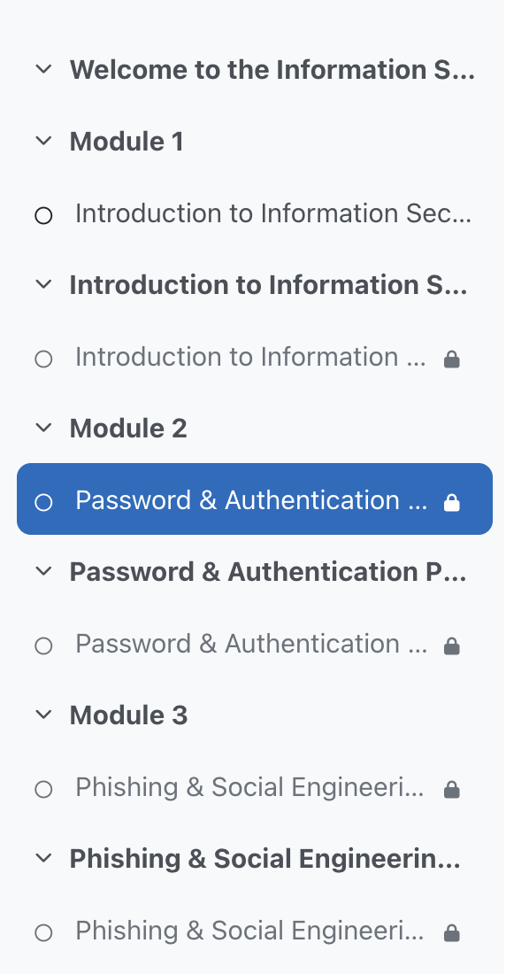

- The course should be interactive with modules and quizzes and also videos - done
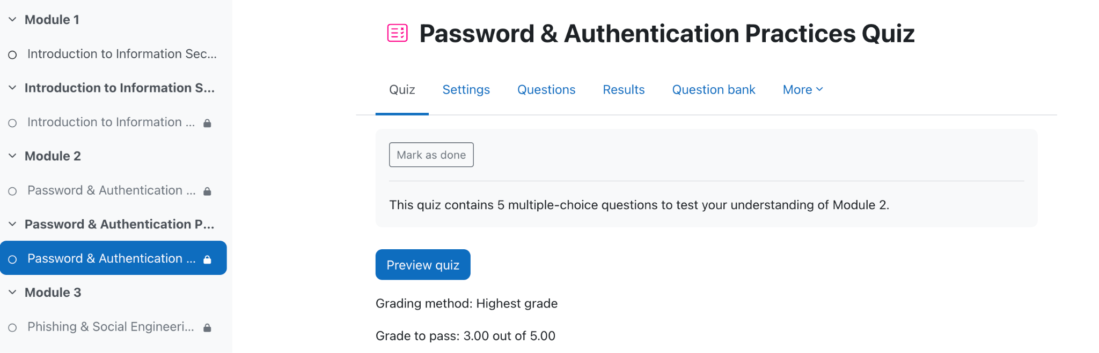

- 

7. All the users list we can check, and how much courses each person had completed. - done

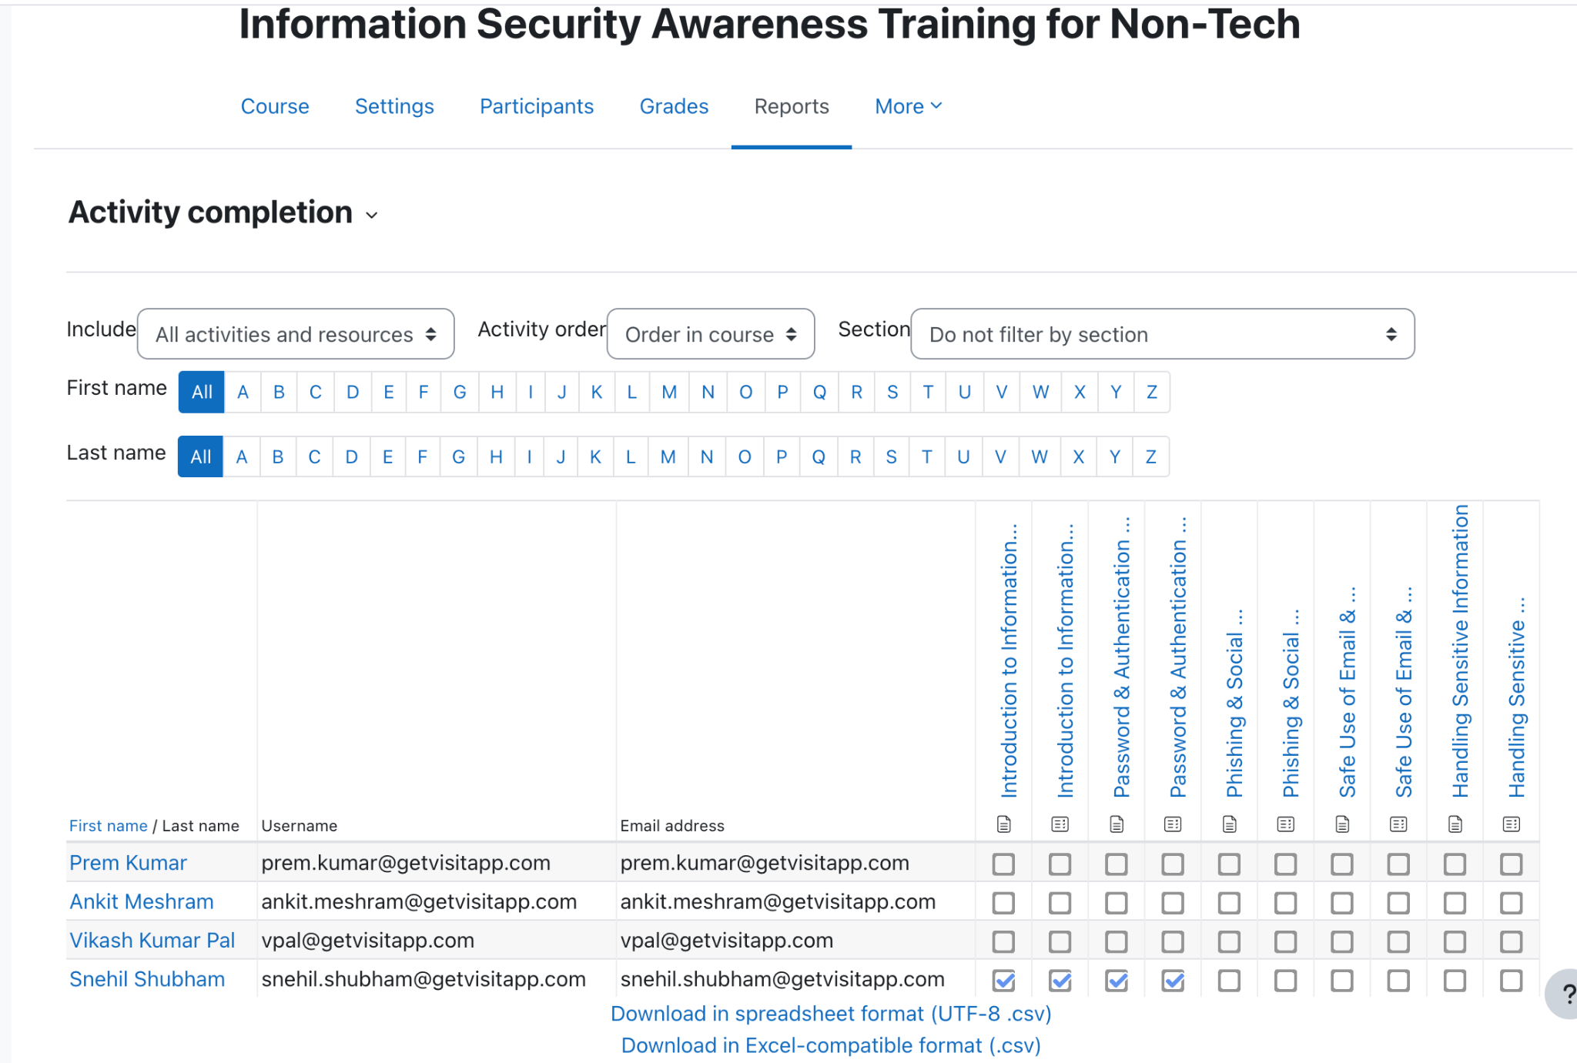

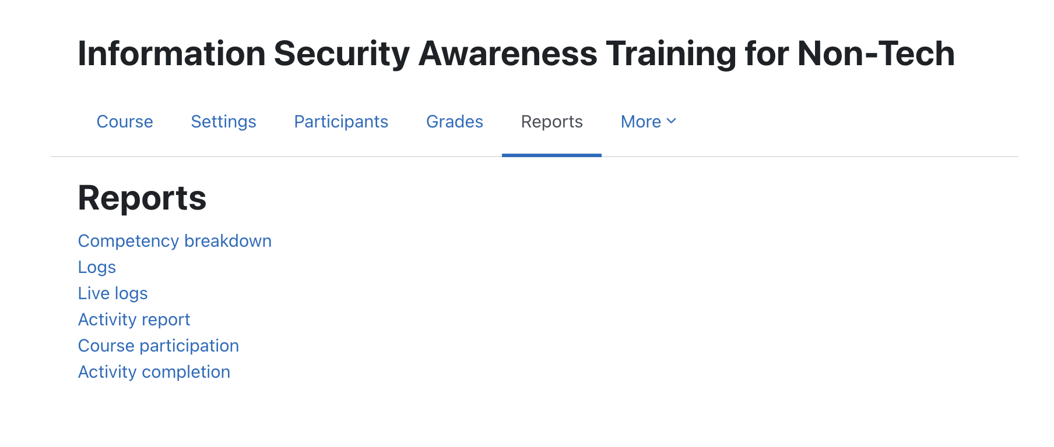

Currently we have moodle running in the Demo Applications server.

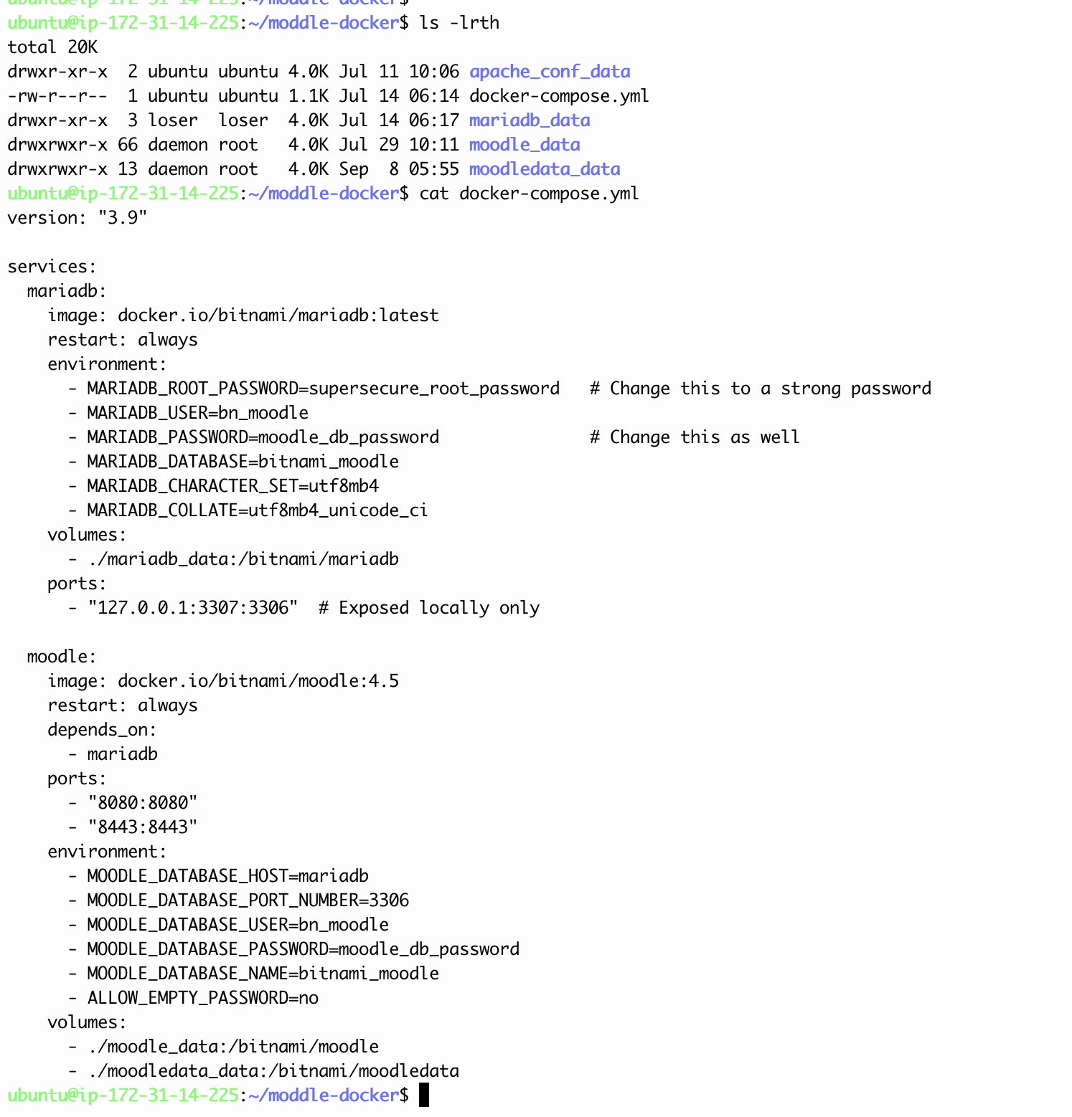

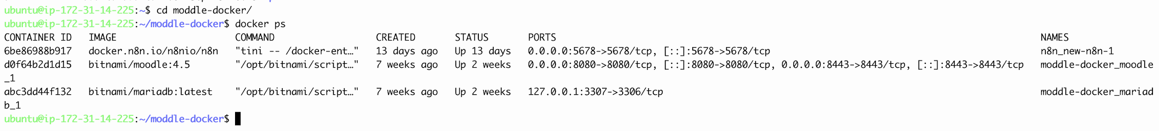

We have migrated moodle to prod server - Jenkins server
ubuntu@ip-172-41-0-71:~/new$ ls -lrth
total 16K
drwxr-xr-x 3 1001 1001 4.0K Sep 15 11:51 mariadb_data
-rw-r--r-- 1 ubuntu ubuntu 1.2K Sep 15 12:10 docker-compose.yml
drwxr-xr-x 66 daemon root 4.0K Sep 15 12:25 moodle_data
drwxr-xr-x 13 daemon root 4.0K Sep 15 12:29 moodledata_data
ubuntu@ip-172-41-0-71:~/new$ cat docker-compose.yml

version: "3.9"

services:
mariadb:
image: docker.io/bitnami/mariadb:latest
restart: always
environment:
- MARIADB_ROOT_PASSWORD=supersecure_root_password # Change this to a strong password
- MARIADB_USER=bn_moodle
- MARIADB_PASSWORD=moodle_db_password # Change this as well
- MARIADB_DATABASE=bitnami_moodle
- MARIADB_CHARACTER_SET=utf8mb4
- MARIADB_COLLATE=utf8mb4_unicode_ci
volumes:
- ./mariadb_data:/bitnami/mariadb
ports:
- "127.0.0.1:3307:3306" # Exposed locally only

moodle:
image: docker.io/bitnami/moodle:4.5
restart: always
depends_on:
- mariadb
ports:
- "8090:8080"
- "8443:8443"
environment:
- MOODLE_DATABASE_HOST=mariadb
- MOODLE_DATABASE_PORT_NUMBER=3306
- MOODLE_DATABASE_USER=bn_moodle
- MOODLE_DATABASE_PASSWORD=moodle_db_password
- MOODLE_DATABASE_NAME=bitnami_moodle
- ALLOW_EMPTY_PASSWORD=no
- MOODLE_SKIP_BOOTSTRAP=yes # ✅ Skip installation, use existing DB/data
volumes:
- ./moodle_data:/bitnami/moodle
- ./moodledata_data:/bitnami/moodledata

ubuntu@ip-172-41-0-71:~/new$

Permissions we have changed - very imp
sudo chown -R daemon:root ~/new/moodle_data

sudo chown -R daemon:root ~/new/moodle_data

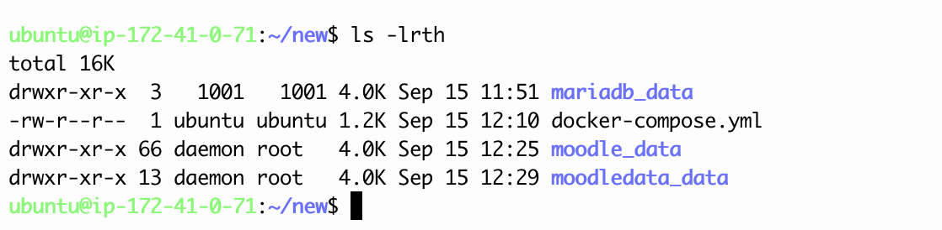

Also we have changed the config.php file

ubuntu@ip-172-41-0-71:~/new/moodle_data$ cat config.php
<?php // Moodle configuration file

unset($CFG);
global $CFG;
$CFG = new stdClass();
$CFG->wwwroot = 'https://lms.getvisitapp.com';
$CFG->sslproxy = true;
$CFG->dbtype = 'mariadb';
$CFG->dblibrary = 'native';
$CFG->dbhost = 'mariadb';
$CFG->dbname = 'bitnami_moodle';
$CFG->dbuser = 'bn_moodle';
$CFG->dbpass = 'moodle_db_password';
$CFG->prefix = 'mdl_';
$CFG->dboptions = array (
'dbpersist' => 0,
'dbport' => 3306,
'dbsocket' => '',
'dbcollation' => 'utf8mb4_unicode_ci',
);

if (empty($_SERVER['HTTP_HOST'])) {
$_SERVER['HTTP_HOST'] = '127.0.0.1:8090';
}
if (isset($_SERVER['HTTPS']) && $_SERVER['HTTPS'] == 'on') {
$CFG->wwwroot = 'https://' . $_SERVER['HTTP_HOST'];
} else {
$CFG->wwwroot = 'http://' . $_SERVER['HTTP_HOST'];
}
$CFG->dataroot = '/bitnami/moodledata';
$CFG->admin = 'admin';

$CFG->directorypermissions = 02775;

require_once(__DIR__ . '/lib/setup.php');

// There is no php closing tag in this file,
// it is intentional because it prevents trailing whitespace problems!

ubuntu@ip-172-41-0-71:~/new/moodle_data$

ubuntu@ip-172-41-0-71:~/new/moodle_data$ docker-compose down - to bring docker container down

ubuntu@ip-172-41-0-71:~/new/moodle_data$ docker-compose up -d - to bring docker container up

ubuntu@ip-172-41-0-71:~/new/moodle_data$ docker ps
CONTAINER ID IMAGE COMMAND CREATED STATUS PORTS NAMES
efe6c2ff8345 bitnami/moodle:4.5 "/opt/bitnami/script…" 18 minutes ago Up 18 minutes 0.0.0.0:8443->8443/tcp, :::8443->8443/tcp, 0.0.0.0:8090->8080/tcp, [::]:8090->8080/tcp new_moodle_1
545eb05fe68e bitnami/mariadb:latest "/opt/bitnami/script…" 18 minutes ago Up 18 minutes 127.0.0.1:3307->3306/tcp new_mariadb_1
ubuntu@ip-172-41-0-71:~/new/moodle_data$

To check the logs

ubuntu@ip-172-41-0-71:~/new/moodle_data$ docker logs <container name>

